ASSIGNMENT – 8.2
AI ASSISTED CODING
NAME : G.Harsha vardhan
HALLTICKECT NO : 2403A52313 BATCH NUMBER : 01
COURSE CODE : 24CS002PC215 PROGRAM NAME : B.TECH
YEAR/SEM : 2ND AND 3RD

TASK 1
Use AI to generate test cases for a function is_prime(n) and then implement the function.
Requirements:
- Only integers > 1 can be prime.
- Check edge cases: 0, 1, 2, negative numbers, and large primes.
PROMPT:
Generate test cases for a function is_prime(n) and then implement the function.
The function should return True if the input integer n is prime and False otherwise.
Only integers greater than 1 can be prime. Include test cases for edge cases: 0, 1, 2, negative numbers, and large primes.
CODE:
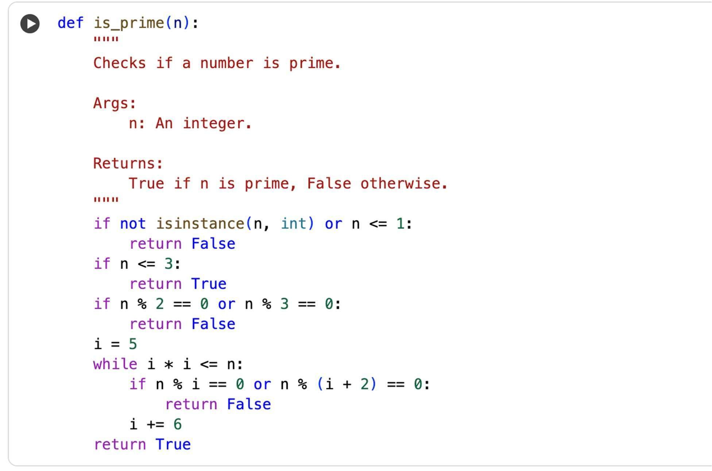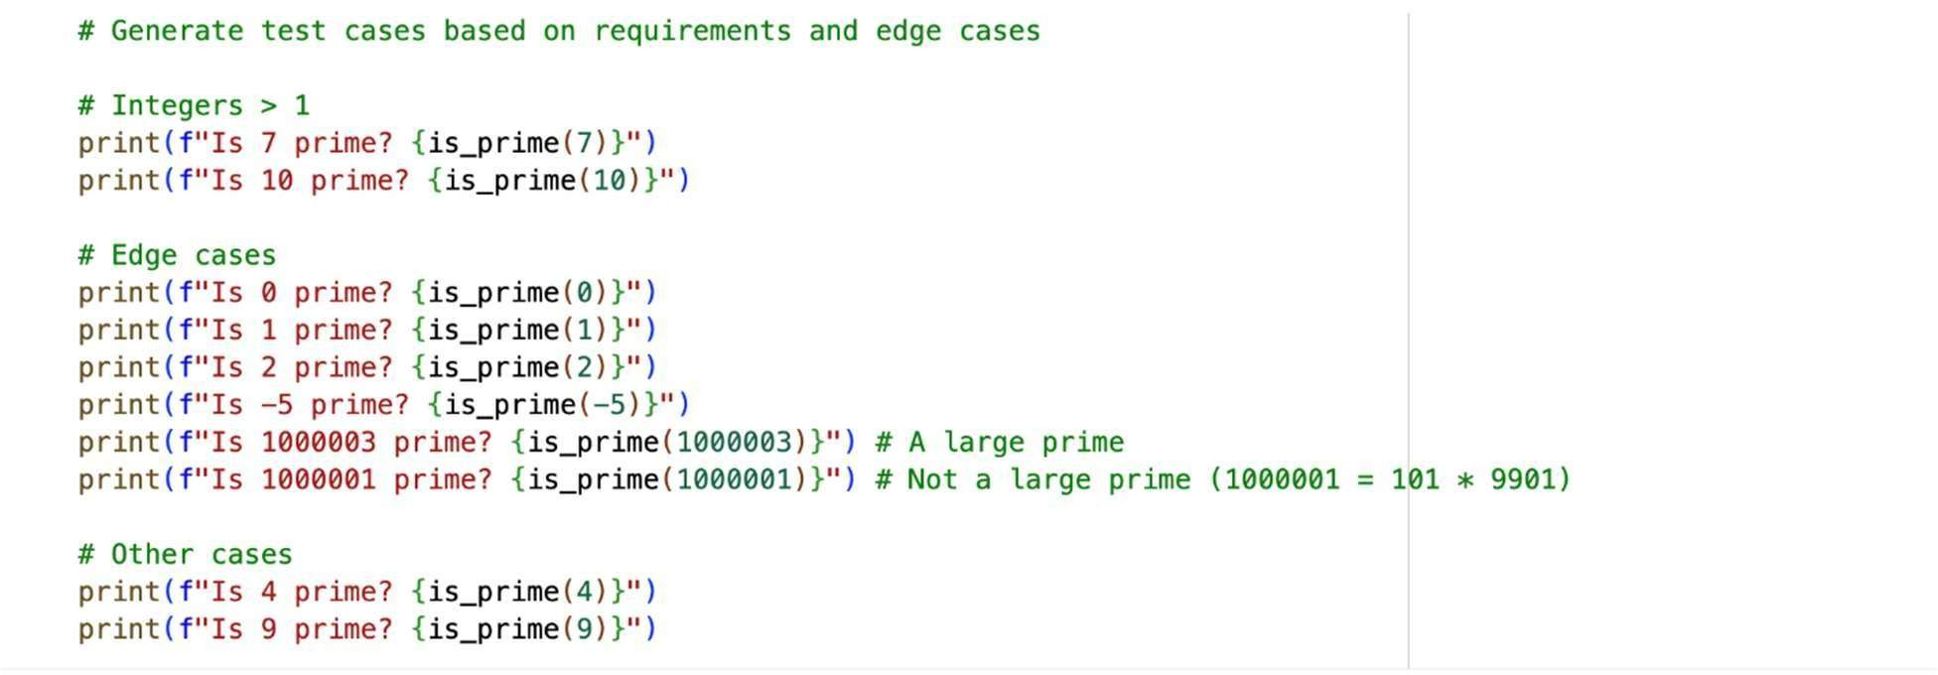

OUTPUT:
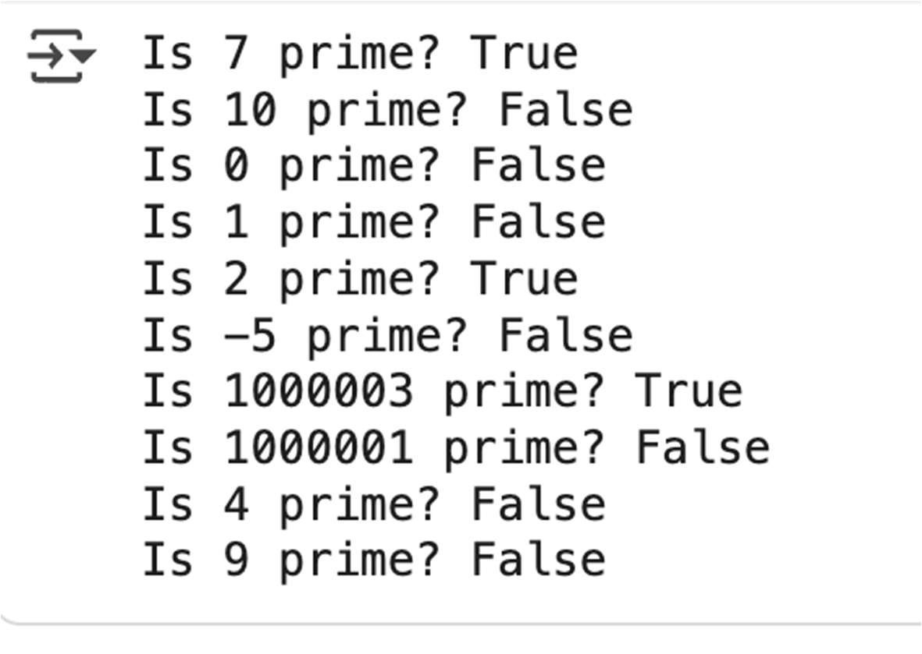
EXPLANATION:
The first code cell defines the is_prime function, which efficiently checks if an integer is a prime number. The second code cell provides various test cases to verify the is_prime function's correctness, including edge cases like 0, 1, and negative numbers, as well as large prime and non-prime numbers.

TASK 2
Ask AI to generate test cases for celsius_to_fahrenheit(c) and fahrenheit_to_celsius(f).
Requirements
- Validate known pairs: 0°C = 32°F, 100°C = 212°F.
- Include decimals and invalid inputs like strings or None

PROMPT:
Generate test cases and implement functions for converting between Celsius and Fahrenheit. Include test cases for known pairs (0°C = 32°F, 100°C = 212°F), decimals, and invalid inputs (strings, None).

CODE:
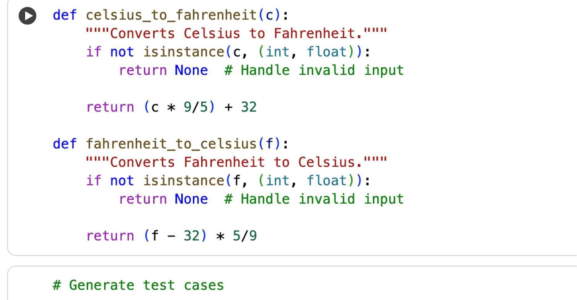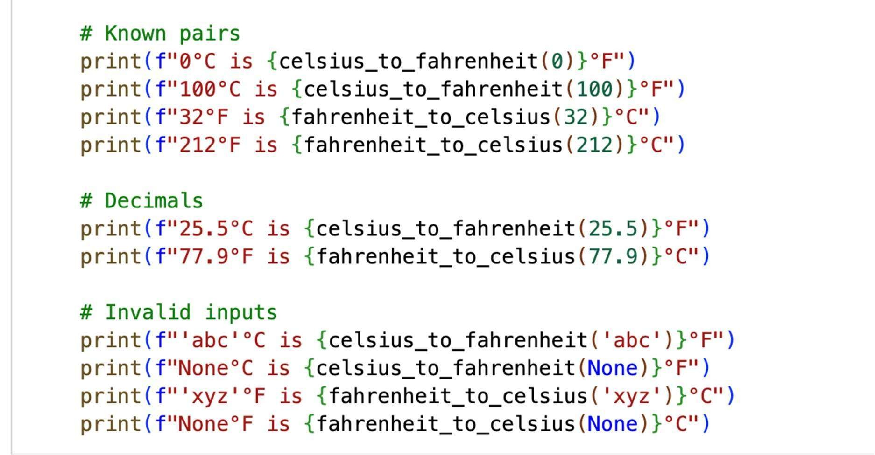
OUTPUT:
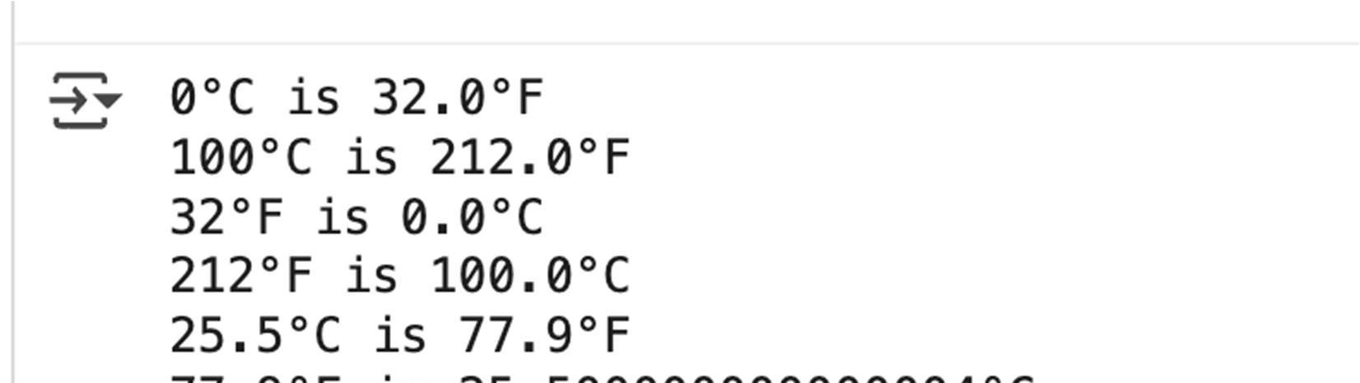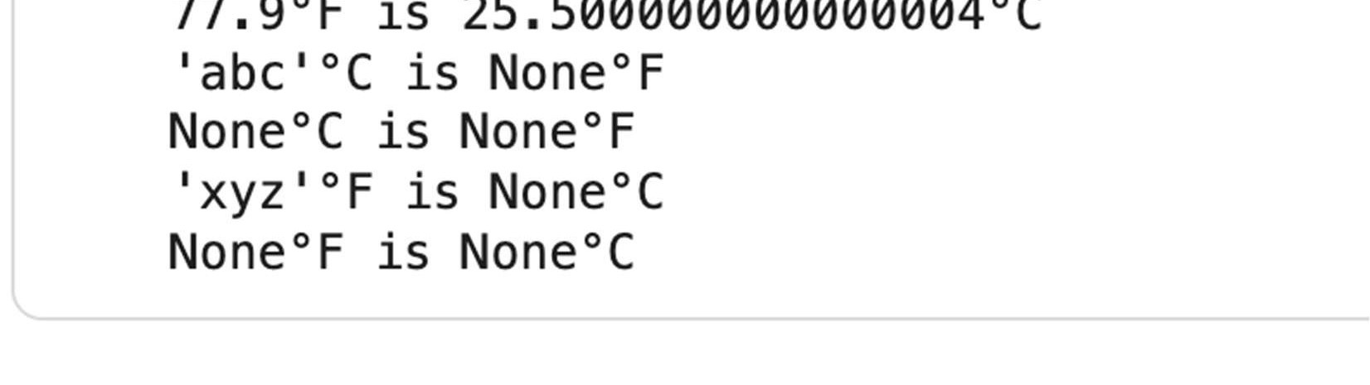
EXPLANATION:
The first code cell defines two functions:
celsius_to_fahrenheit and fahrenheit_to_celsius for converting temperatures,
including handling invalid inputs. The second code cell contains test cases for these functions, verifying known conversions, decimal values, and how invalid inputs are handled.

TASK 3
Use AI to write test cases for a function count_words(text) that returns the number of words in a sentence.
Requirement
Handle normal text, multiple spaces, punctuation, and empty strings

PROMPT:
Generate test cases for a function count_words(text) that returns the number of words in a sentence, handling normal text, multiple spaces, punctuation, and empty strings. Then, implement the function and test it with the generated test cases.
CODE:
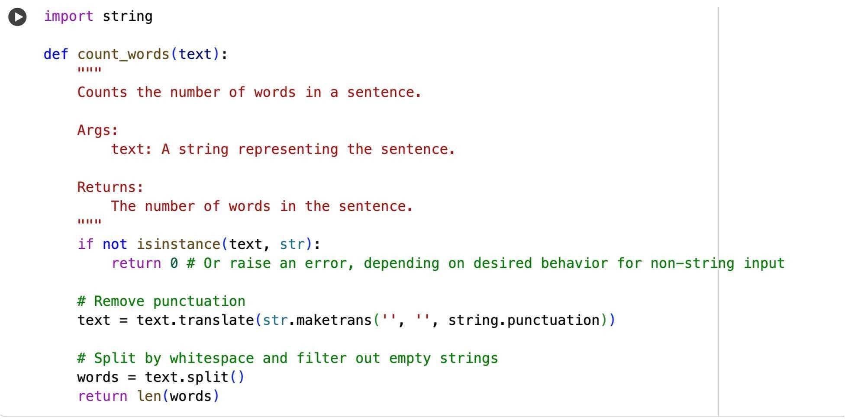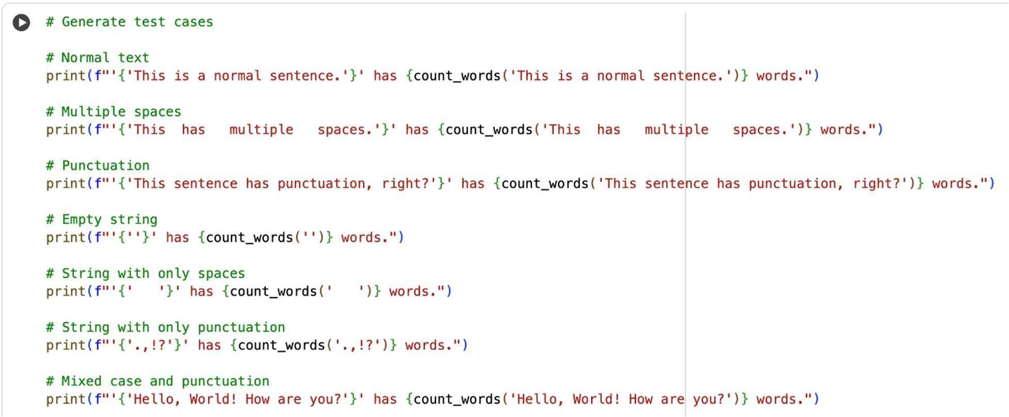
OUTPUT:
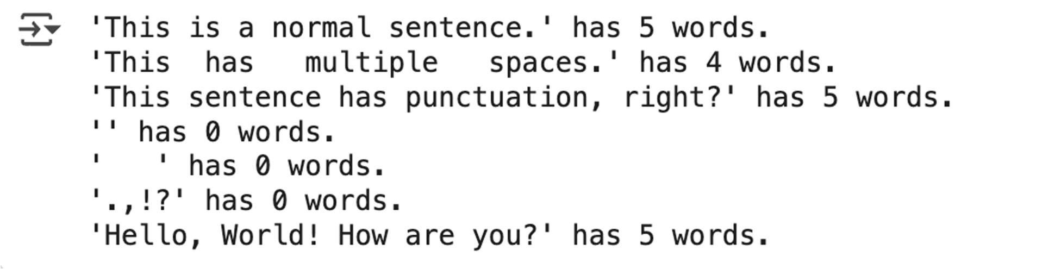
EXPLANATION:
This code cell provides test cases for the count_words function. It calls the function with different types of strings, including:
• | A normal sentence.
• | A sentence with multiple spaces between words.
• | A sentence with punctuation.
• | An empty string.
• | A string containing only spaces.
• | A string containing only punctuation.
• | A string with mixed case and punctuation.
For each test case, it prints the input string and the number of words returned by the count_words function, allowing you to verify that the function handles these different scenarios correctly.

TASK 4
Generate test cases for a BankAccount class with:
Methods:
deposit(amount) withdraw(amount) check_balance() Requirements:
- Negative deposits/withdrawals should raise an error.
- Cannot withdraw more than balance

PROMPT:
Generate test cases and implement a BankAccount class with deposit, withdraw, and check_balance methods, ensuring negative deposits/withdrawals raise errors and withdrawals do not exceed the balance.
CODE:
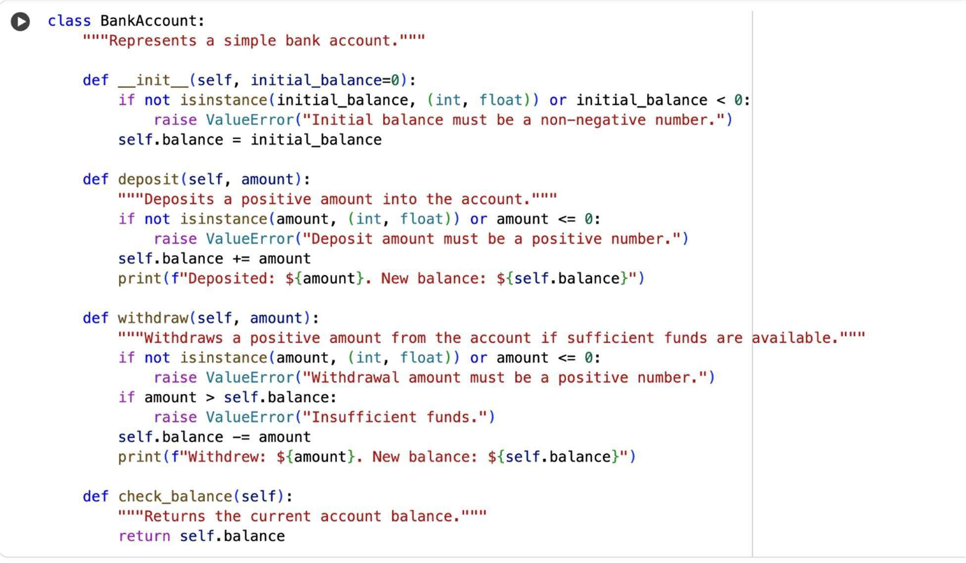
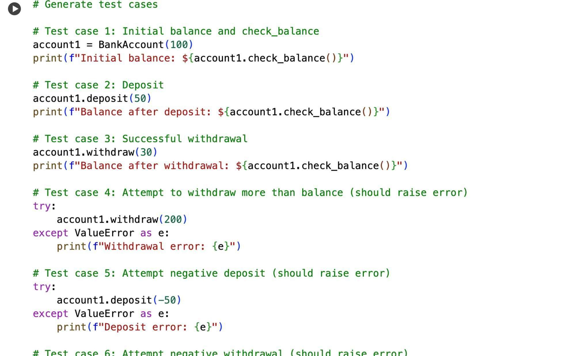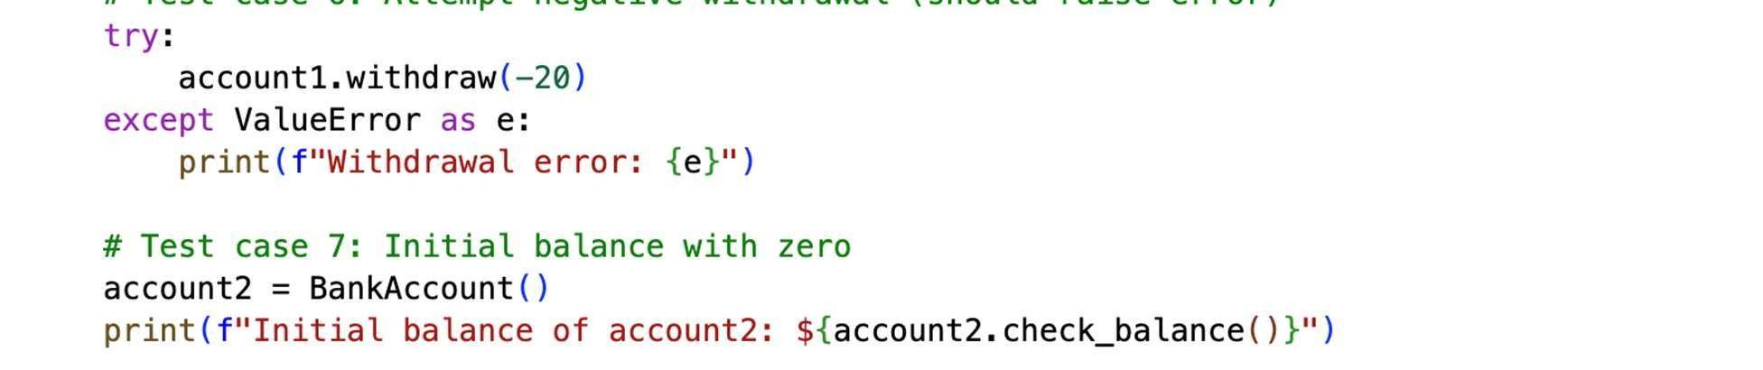
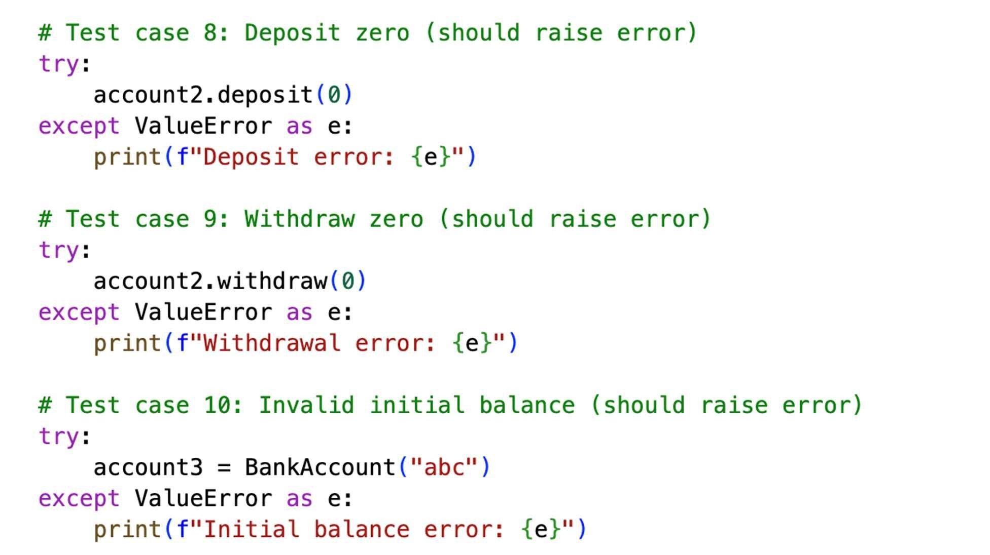
OUTPUT:
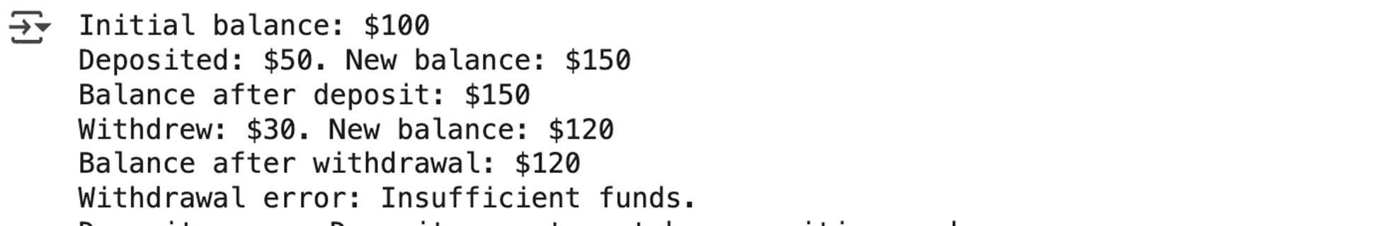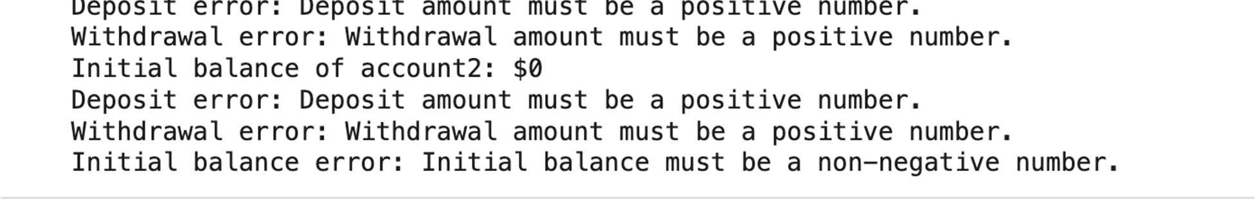
EXPLANATION:
This code cell contains various test cases for the BankAccount class. It demonstrates how to:
• | Create a BankAccount instance with an initial balance and check the balance.
• | Deposit a positive amount.
• | Withdraw a positive amount successfully.
• | Handle errors for attempting to withdraw more than the balance, depositing a negative amount, withdrawing a negative amount, and attempting to deposit or withdraw zero.
• | Handle errors for providing an invalid initial balance.
These test cases help verify that the BankAccount class behaves as expected under different scenarios, including error conditions.

TASK 5
Generate test cases for is_number_palindrome(num), which checks if an integer reads the same backward. Examples:
121 → True
123 → False
0, negative numbers → handled gracefully
PROMPT:

CODE:
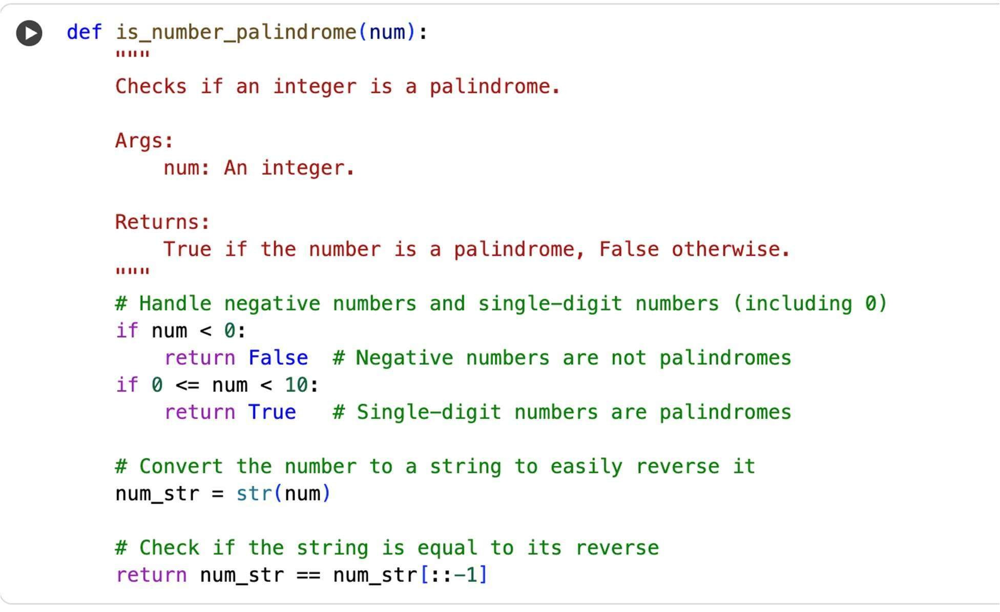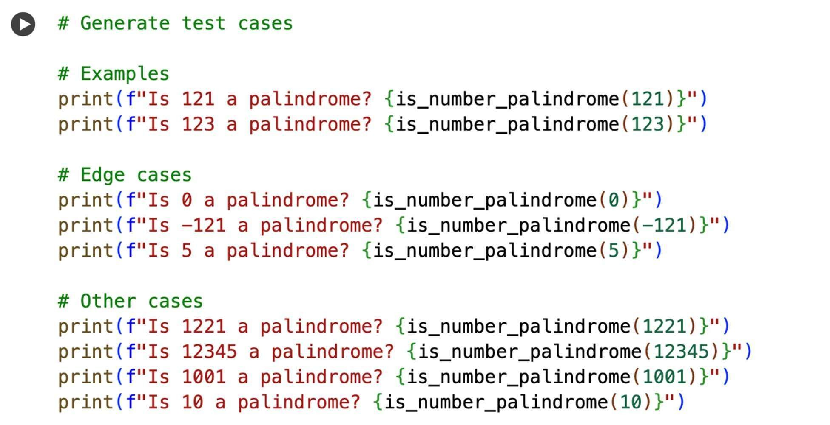

OUTPUT:
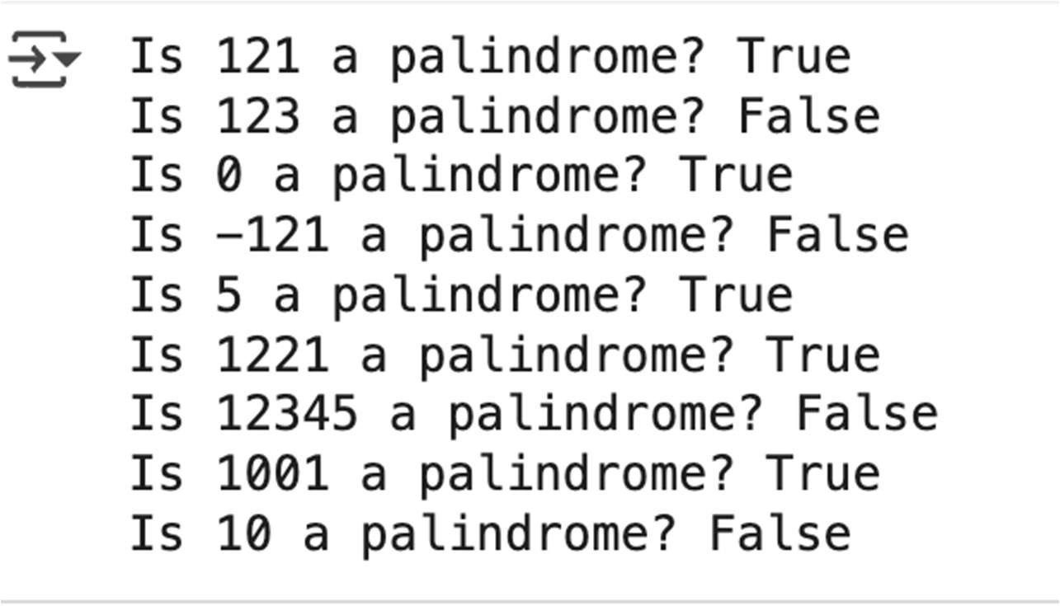
EXPLANATION:
This code cell contains test cases for the is_number_palindrome function. It calls the function with various integer inputs, including:
- The examples provided (121 and 123).
- Edge cases like 0, a negative number (-121), and a single-digit positive number (5).
- Other numbers that are palindromes (1221, 1001) and not palindromes (12345, 10).
For each input, it prints whether the number is a palindrome based on the function's output, allowing you to verify the function's behavior for different scenarios.

